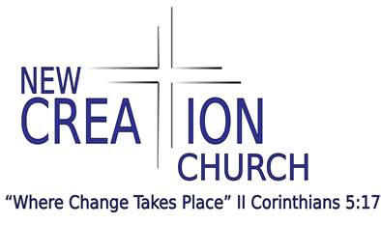

New Creation Church is currently seeking a Pastor to lead our congregation and provide spiritual counseling. Since you will be a public representative of our faith, you must have a deep understanding and passion for the beliefs of our church.
We believe New Creation Church is called to worship God, proclaim the Gospel of the revelation of God through Jesus Christ, minister and serve the community in the name of Jesus Christ, and teach it to all.
Our mission is given to us by Christ in the Great Commandment, (Matthew 28:18-20) to go where lost people are and to make disciples of every kind of people. Our manner and motivation are given in the Great Commandment (Matthew 22:36-40). Our love for God compels us to love others.
We strive to show the love of Christ, share the Gospel of Christ, see people receive Christ, and grow healthy disciples while being a blessing to the community outside of the four church walls.
Our church model is a house church who meet for worship in private homes as demonstrated in the Bible. We seek to provide an intimate space for Believers to develop close fellowship with others in the midst of taking ownership of their own spiritual growth and first-hand faith.

PASTOR DUTIES AND RESPONSIBILITIES
In this role, you will provide spiritual guidance to congregants. You will be responsible for preaching, teaching, pastoral counseling, administration, planning, and the church to grow and fulfill its purposes. You shall lead the church, the organizations, and all leaders of the church in performing their tasks in worship, proclamation, education, and evangelism. You shall also assist with community outreach efforts.

PASTOR REQUIREMENTS AND QUALIFICATIONS
- High school diploma or GED equivalent
- Formal training in theology or seminary (degree preferred)
- Church ordination
- Deep understanding and passion for our faith
- Experience working for the church as an assistant or associate pastor
- Experience writing and delivering sermons
- Oral presentation skills

SUPPLEMENTAL QUESTIONS
When submitting your resume, please attach a document with your responses to the following questions:
- What is your view on the Apostolic Five Fold Ministry (Ephesians 4:11-13)? Where do you think you fall as to your gift set? Can you provide a copy of the last 2 sermons you’ve preached?
- Given what you know about New Creations current church model, what are your thoughts on house church (Luke 10)?
- What is your denomination?
- Please provide your interpretation of the following scriptures, Acts 2:1-4, 1 Timothy 3:1-7
- Do you believe in the holy trinity?
- What do you think about women in ministry?
- Who is your spiritual covering?

